4th October, 2010

I N V I T A T I O N

to participate in the11th meeting of the European Guitar and Mandolin Youth Orchestra (EGMYO) from 22nd April – 01st May, 2011 in Logroño (Spain)

Dear Ladies and Gentlemen,
dear Music Friends,

the 11th meeting of the European Guitar and Mandolin Youth Orchestra will be held from 22nd of April up to 1st of May, 2011 in Logroño (Spain). The meeting is organized by the European Guitar and Mandolin Association (EGMA) in cooperation with ConTrastes Rioja, Mr. Carlos Blanco Ruiz.

Attached hereto we are sending you the Registration form which we ask you to return filled in clearly as soon as possible. Deadline for registration is November 10th, 2010.

Below mentioned you find the informations about the artistic director, the lecturers, the program and the conditions of participation.

The planned music program for the meeting is:
- Carlos Blanco Ruiz: "Ouverture piece (UA)"
- Joaquin Turina: "La Oración del torero"
- Pedro Chamorro: "Villarejo Suite"
- Oliver Kälberer: "Kali – Closing the Circle"
- Takashi Kubota: "Tanzsuite No. 2"
- probably one more which is not yet fixed

The artistic lecturers are:
- Oliver Kälberer (conductor, Germany)
- Caterina Lichtenberg, (1st mandolin, Germany)
- Juan Carlos Munoz (2nd mandolin, Luxemburg)
- Ugo Orlandi (mandola, Italy)
- Carlos Blanco Ruiz (guitar, Spain)

-2-
Invitation letter EGMYO 2011 in Logroño/Spain 04-10-2010

Permitted instruments are:

- Mandolin
- Bandurria
- Mandola
- Laud Espagnõl
- Guitar
- Double bass

Conditions of Participation:

- Advanced performance level and experience as orchestral player
- Participant’s contribution amounting € 240,00
- Travel expenses to Logroño on own account
- Interested in meeting young people of other countries to work in music and have fun together

At the end of the meeting the organizers plan to have public concerts to perform the musical program at high artistical standard and possibly a CD recording.

We herewith ask interested young players from the age of 16 to 27 years to send in the attached application form with your photo. Please don’t forget to send the photo which is needed by us. You can either send it along with the application form or seperately as jpg. The deadline date is November 10th, 2010.

We have the right to select the players depending on the total numbers of the different instruments, and we have the right to refuse players. You’ll receive the Confirmation Letter latest by end of November, 2010 together with the travel informations to Logroño so that you can book your flight
or railway ticket.

The music sheets will be sent in advance to all accepted participants. You are expected to have practised your part before coming to the EGMYO 2011.

All accepted participants will be expected to have their details of emergency contact numbers, immunisations and any health issues with them. All participants will be expected to accept the rules advised by the responsible people in Logroño.

Hoping to meet you again in Logroño,

Yours
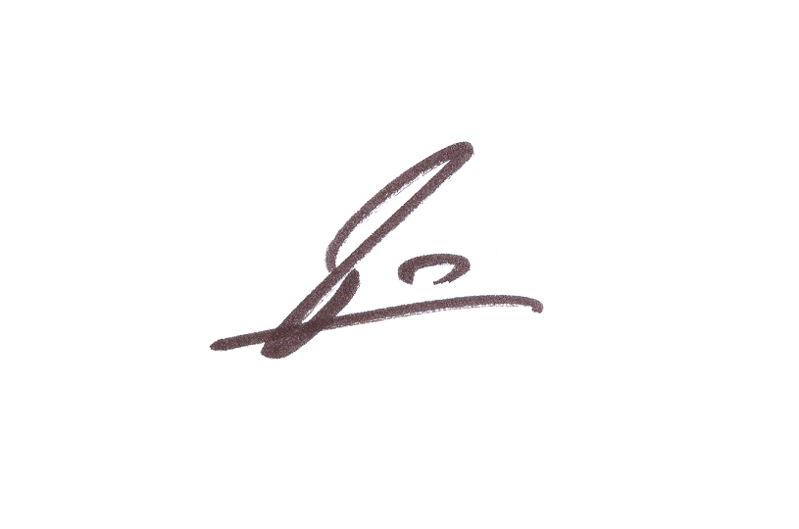
Ruediger Grambow
Executive President of EGMA

